
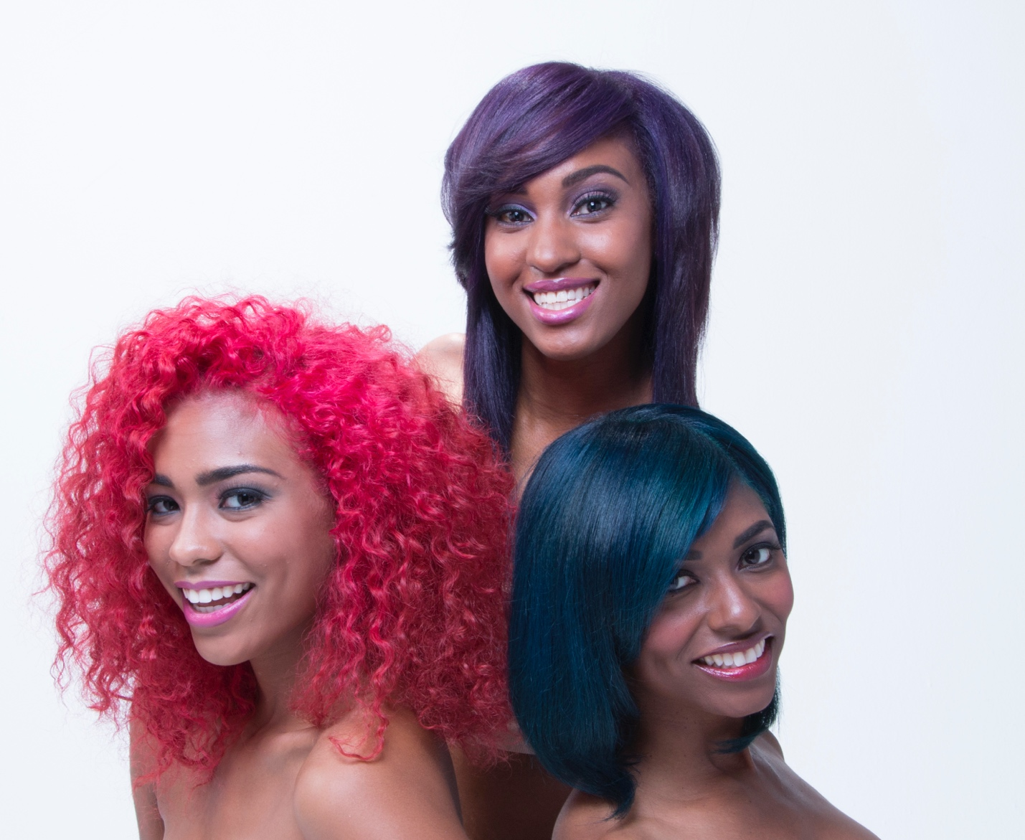
& NBCL/IOC
Presents
VIVID BOLD & AMZAING HAIRCOLOR
BOLD & AMAZING HAIRCOLOR

Rules and Regulations:
Eligibility:
- All applicants must be licensed Cosmetologist and enrolled in NBCL Institute.
- No admission fee
- Applicant and model must be at least-twenty one (21) years of age
- Must have read and, understood and agreed to each and all terms and conditions of the Contest
HOW TO ENTER/Contest Rules
- Applications will be available via email through the Director of Deans of the:
The National Beauty Culturists’ League Institute of Cosmetology
mercedestoregano@hotmail.com

Applications and before video of Model must be submitted by July 1st
- Application ( name and address, email and phone number, license #, signature of applicant and model, Bigen Vivid Semi shade selected, details models hair and technique to be used)
- Patch Test of model required (48) hours in advance. Live presentation, form signed by both and dated
- Before Video of model
- All coloring, cutting and designing work must be performed on a human model “solely “by you without assistance from anyone else.
- No video editing
Judging Criteria:
NBCL/IOC and Hoyu representatives will select final winners, in their sole and absolute discretion, based on the following criteria:
- Proper coloring technique
- Cutting and or designing technique
- Professional and Presentable “Total Look” , Formula, Casual or Sporty

Announcement of Winners:
Winners will be announce on Monday July 15th at “The Front Center Presentation” at 9:00am
All entries and their Model Must be present to win.
1st Place: $300.00 2nd Place: $100.00 3rd Place $50.00 (all will received Bigen Product)

Terms and Conditions:

Your application is NOT transferable. Upon submission, all photos, videos and digital materials shall become the exclusive property of the NBCL/IOC and Hoyu America. NBCL/IOC and Hoyu America reserve the right to all submitted photos and videos or anything pertaining to this Contest, and they remain exclusive property of NBCL/IOC and Hoyu America. Submitted Videos or Photos will not be returned.
“Bigen Presents” “Vivid, Bold and AMZAING Hair color”
NBCL/IOC and Hoyu America reserve the right to collect information and use of any photos and videos from before, during and after the “Contest” for marketing collateral and including all websites, social media, photographic and digital content.
NBCL/IOC reserves the right to change and/or modify any terms and/or conditions governing the “Contest” without any notification to applicants. If changes should occur they will be posted at www.nbcl.info.com
For Full Terms & Conditions please visit www.nbcl.info.com
Contact: Dr. Mercedes Toregano – Director of Deans mercedestoregano@hotmail.com
Dr. Willie C. Singleton – Lead Instructor of IOC mrwillies@comcast.net

Submit Entry Form to Director of Deans: Dr. Mercedes Toregano mercedestoregano@hotmail.com

M.I
LAST NAME
FIRST NAME

STREET
CITY
STATE
ZIP

EMAIL
CELL PHONE

LICENSE #
STATE OF ISSUE
MODEL NAME

